

FALCON’s Response to Flipkart for Supply of Telescopic Belt Conveyor + Dynamic Profiler – 1000 PPH
July 15, 2024

Kind Attention –
M/s Flipkart

Offer Ref: F24-343; Date: 15-07-2024

Subject – Techno -Commercial Offer of Telescopic Belt conveyor integrated with Dynamic profiler.

We are pleased to submit our Techno-Commercial Offer in response to your RFP.
As you will note, we have done an in-depth data analysis and evaluated various solution options best suited for your requirements, along with the information collected during the virtual meetings and discussions with you, we have put together a detailed technical proposal laid out in various sections and sequenced to enable you to understand our proposed solution and to re-enforce our commitment to being your partner in this strategic initiative.
In subsequent sections, we have highlighted the capabilities and experiences of Falcon Autotech with sections on our Intra-logistics Automation Technologies and references.
To conclude, I would like to add my personal commitment on behalf of Falcon Autotech. As we move through the RFP process, please do not hesitate to contact me and my team. We will be pleased to assist you with any further information or clarifications that you might have.
Best Regards,
Sandeep Bansal
Chief Business Officer

Response to RFP for TBC with Dynamic profiler – 1000 PPH

Proposal Reference – F24-00343

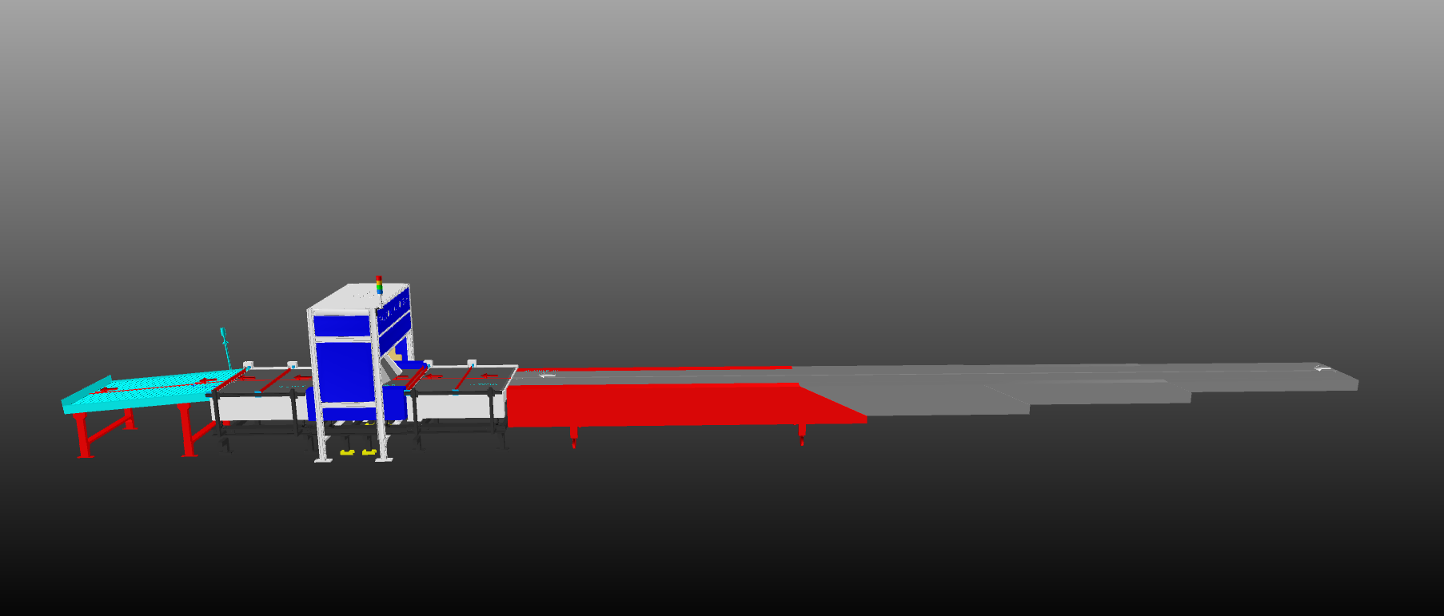

G Level

Table of Content
1. Glossary 5
2. Executive Summary 6
3. Company Profile 7
4. Falcon’s Experience and Achievements in Sortation Space Globally 11
5. Reference Projects 13
5.1 Project 1- (CEP Client, India) 13
5.2 Project 2- (Client – E-Commerce, India) 14
5.3 Project 3- (Ecommerce Client, India) 15
5.4 Project 4- (CEP Client, UK) 16
5.5 Project 5- (CEP Client, Sydney) 17
6. Handled Shipment Spectrum 18
6.1 Shipments to be loaded on Sorter shall have the following characteristics: 19
6.2 Shipment not loadable on the sorter 19
7. Proposed System Description 20
7.1 Objective 20
7.2 Summary of the System 20
7.3 Main benefits of the proposed solution 20
8. System Components 21
8.1 Telescopic Belt Conveyor 21
8.2 Orientation Conveyor and Output Conveyor 22
8.3 Weighing Conveyor 23
8.4 Auto Barcode Scanning System 24
8.5 Idler Roller Conveyor 25
9. Proposed System Technical Details (Shipment Sorter) 26
9.1 Mechanical equipment 26
9.2 Electrical Equipment 26
9.3 Control System 26
10. Key Components Make 27
11. Program Organisation 27
12. Commercial Terms 27
12.1 Price Sheet 27
12.2 Payment Terms 28
13. Warranty Period 28
14. Exclusions 29

Glossary

S. No. | Term | Description
1 | RFP | Request For Proposal
2 | PPH | Shipments Per Hour
3 | TBC | Telescopic Belt Conveyor
4 | AC | Alternating Current
5 | DC | Direct Current
6 | PLC | Programmable Logic Controller
7 | IT | Information Technology
8 | BOQ | Bill Of Quantity
9 | I/O | Input/ Output
10 | MDR | Motor Driven Roller
11 | DAP | Design Approval Phase

Executive Summary
Falcon Autotech is pleased to confirm its great interest in responding to this Flipkart RFQ of Telescopic Belt conveyor with integrated Dynamic Profiler. Our team has been working closely with the relevant stakeholders, with a clear commitment to listening, understanding your needs, and ensuring this project's success.

Our solution is based on the following key characteristics:

TBC & Dynamic Profiler 1000 PPH:-

•One Telescopic Belt Conveyor.
•Dynamic profiler with Auto Scanning, volume measurement & Weighing.
• Idler roller conveyor.

- Commitment to quality systems

Demonstrating Falcon's clear commitment to the Flipkart satisfaction, the shipment sortation system, parts and services will be under warranty for 12 months from installation go-live.

- A strong and already successful partnership between Flipkart & Falcon

Flipkart has been Falcon's customer since long and using multiple Falcon Systems and now four new shipment sortation system of 20,000 PPH is being installed at the Ulluberia, Jaipur & Surat location along with four conveyor automation & VDS system at four strategic location of the Flipkart network. For each of these projects, several advanced tools to improve the service's quality and efficiency are provided: Service Desk, Hotline support, remote access, regular governance meetings and monthly reports.

Company Profile

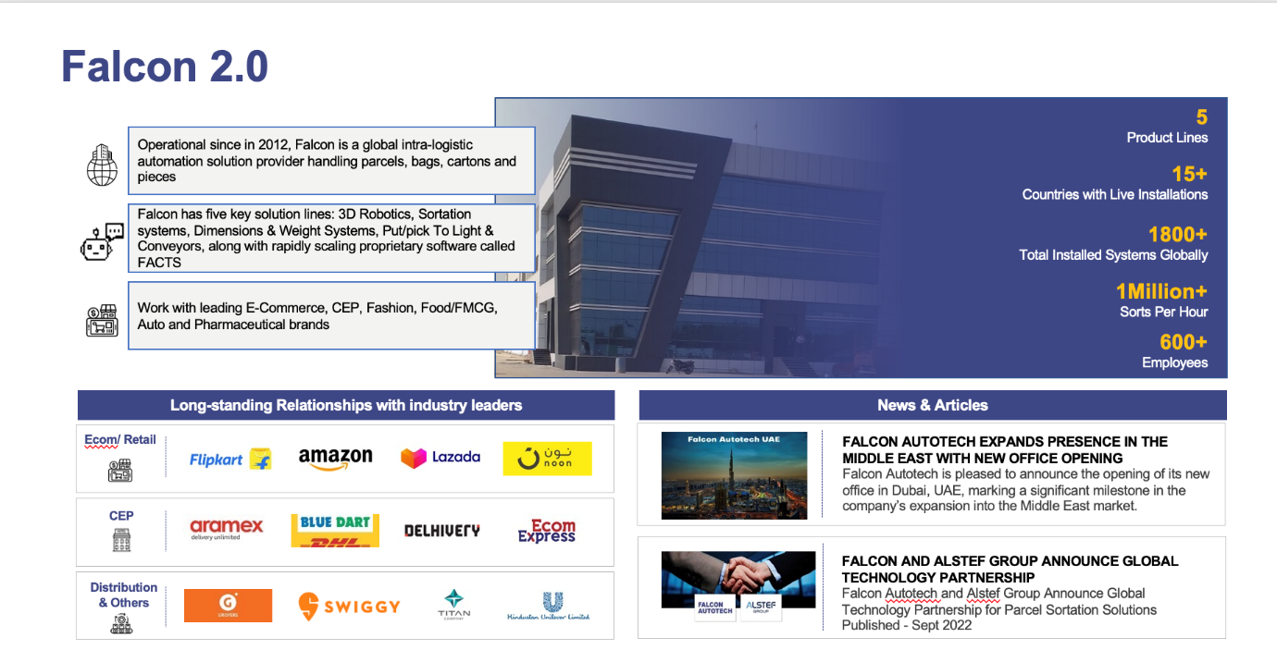
Falcon Autotech (Falcon) is a global intralogistics automation solutions company. With over 10 years of experience, Falcon has worked with some of the most innovative brands in E-Commerce, CEP, Fashion, Food/FMCG, Auto and Pharmaceutical Industries. With our proprietary software and robust hardware integration capabilities, Falcon designs, manufactures, supplies, implements, and maintains world-class warehouse automation systems globally. Falcon’s strong research and development team and the continuous focus on innovation reflect our strong solution line around Sortation, Robotics, Conveying, Vision Systems and IOT. Falcon has done over 1,800 installations across 15 countries on four continents.
Falcon Autotech is currently among the top 15 intralogistics automation company, our vision is to become top 10 intralogistics automation company in our focused product lines.
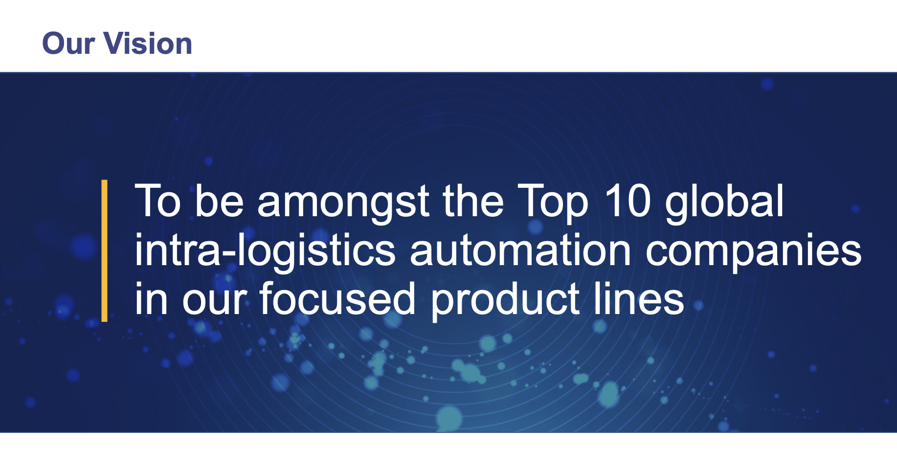

The team started out in 2004 solving special purpose automation problems for clients and later established Falcon Autotech in 2012 with strong focus on building standard technology stack spanning across Hardware, Firmware and Software to tackle bigger Supply Chain problems around warehouse automation and material handling. Over the decade, Falcon has made rapid strides and has carved out a niche in some of the world's most cutting-edge technologies: Sortation, Robotics, Conveying, Vision Systems and IOT.

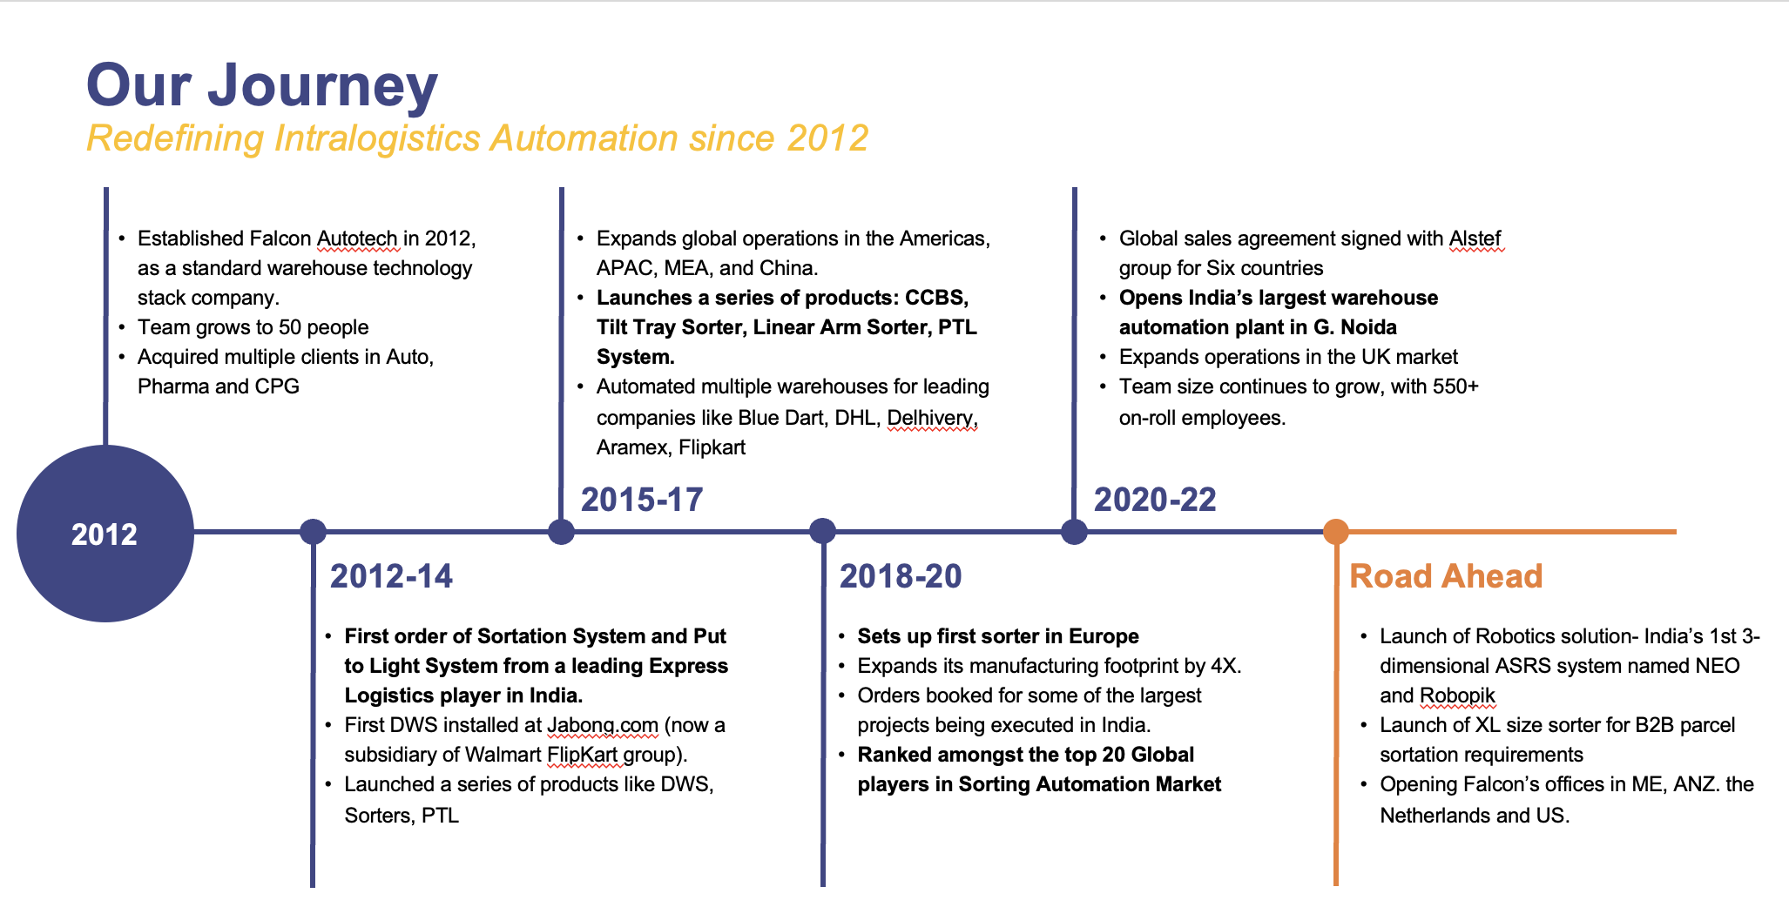

As a leading player in the intra-logistics automation space, Falcon continuously strives to improve the operational efficiencies and accuracies for its clients through its domain knowledge and experience in addition to its wide range of products and solutions. In order to be able to live up to the high expectations set forth by our clients, the team at Falcon realizes the importance of taking up selective applications in focused Industries and deliver world class projects in return.
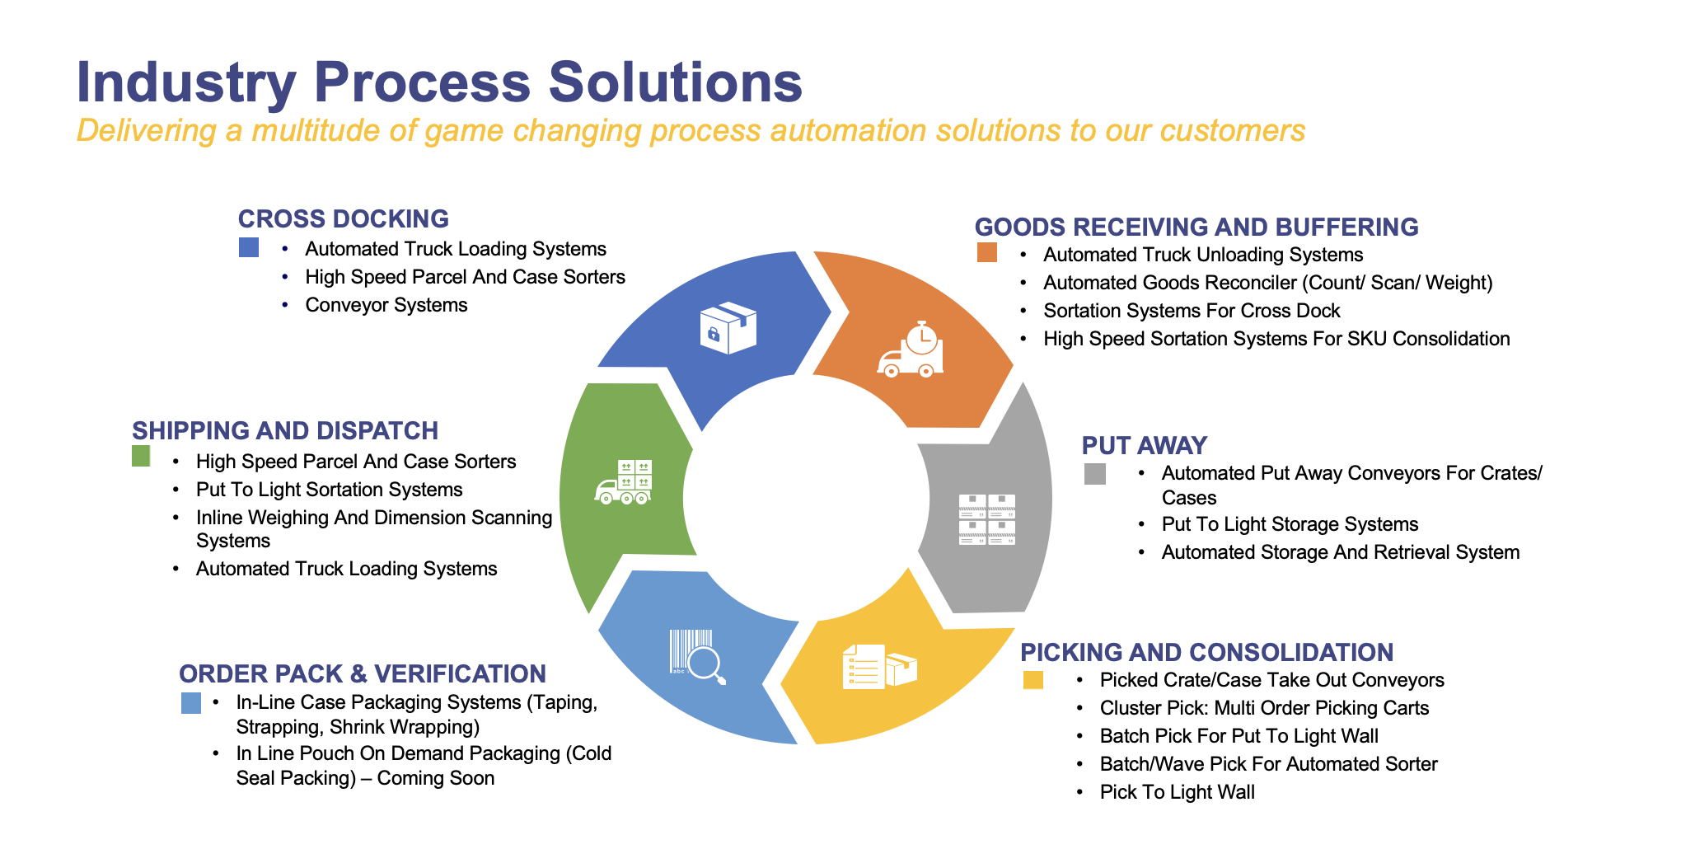

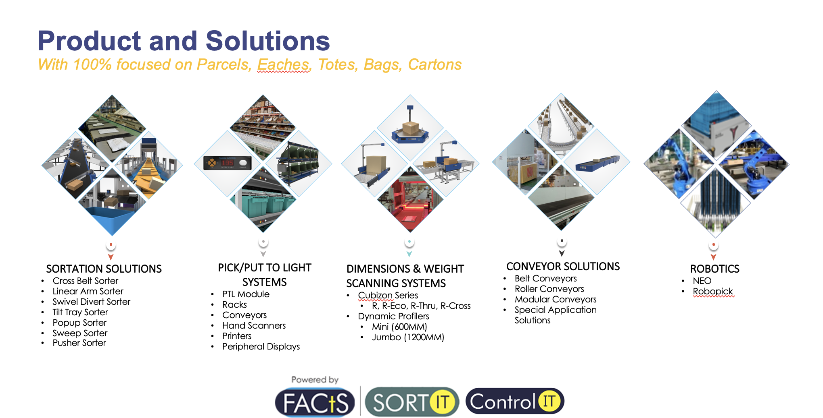

Falcon Autotech has successfully delivered warehouse automation solutions based on smart and innovative combinations of above product lines for effective materials handling, sortation and movement. The process is controlled in real-time by our in house WCS applications. These solutions considerably cut the need for manual operations, improve working conditions and ensure the highest accuracy of the entire process up to final delivery to the recipient.

Over the last 10 years, Falcon has worked with some of the most innovative brands worldwide and has established long standing partnerships. These brands are testimony of our strong focus on delivering superior customer satisfaction and offering end-to-end intralogistics solutions.

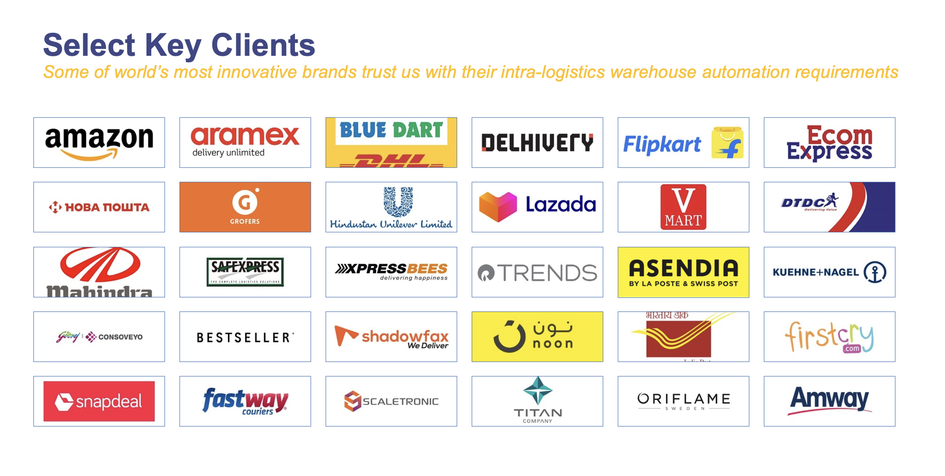

With over 1,800 installations, today Falcon’s systems are used all over the globe. Falcon has highly motivated team of 600+ employees supported by over 15 global partners who help us design, manufacture, deliver and maintain automation solutions globally.

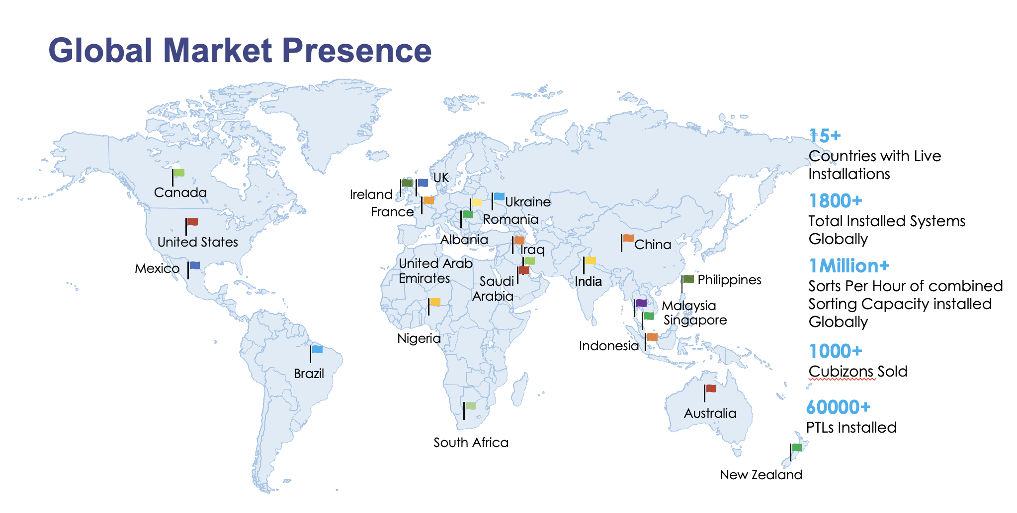

Falcon’s Experience and Achievements in Sortation Space Globally

- Ranked among Top 20 Sortation System Suppliers globally. Only company from APAC/EMEA Region.
- Currently possess one of the World’s largest portfolios in Sortation Technologies: 7 In-house technologies.
- Total installed capacity of 10 million Shipments per day worldwide.
- Only company to be able to offer a Fully Integrated AMS.

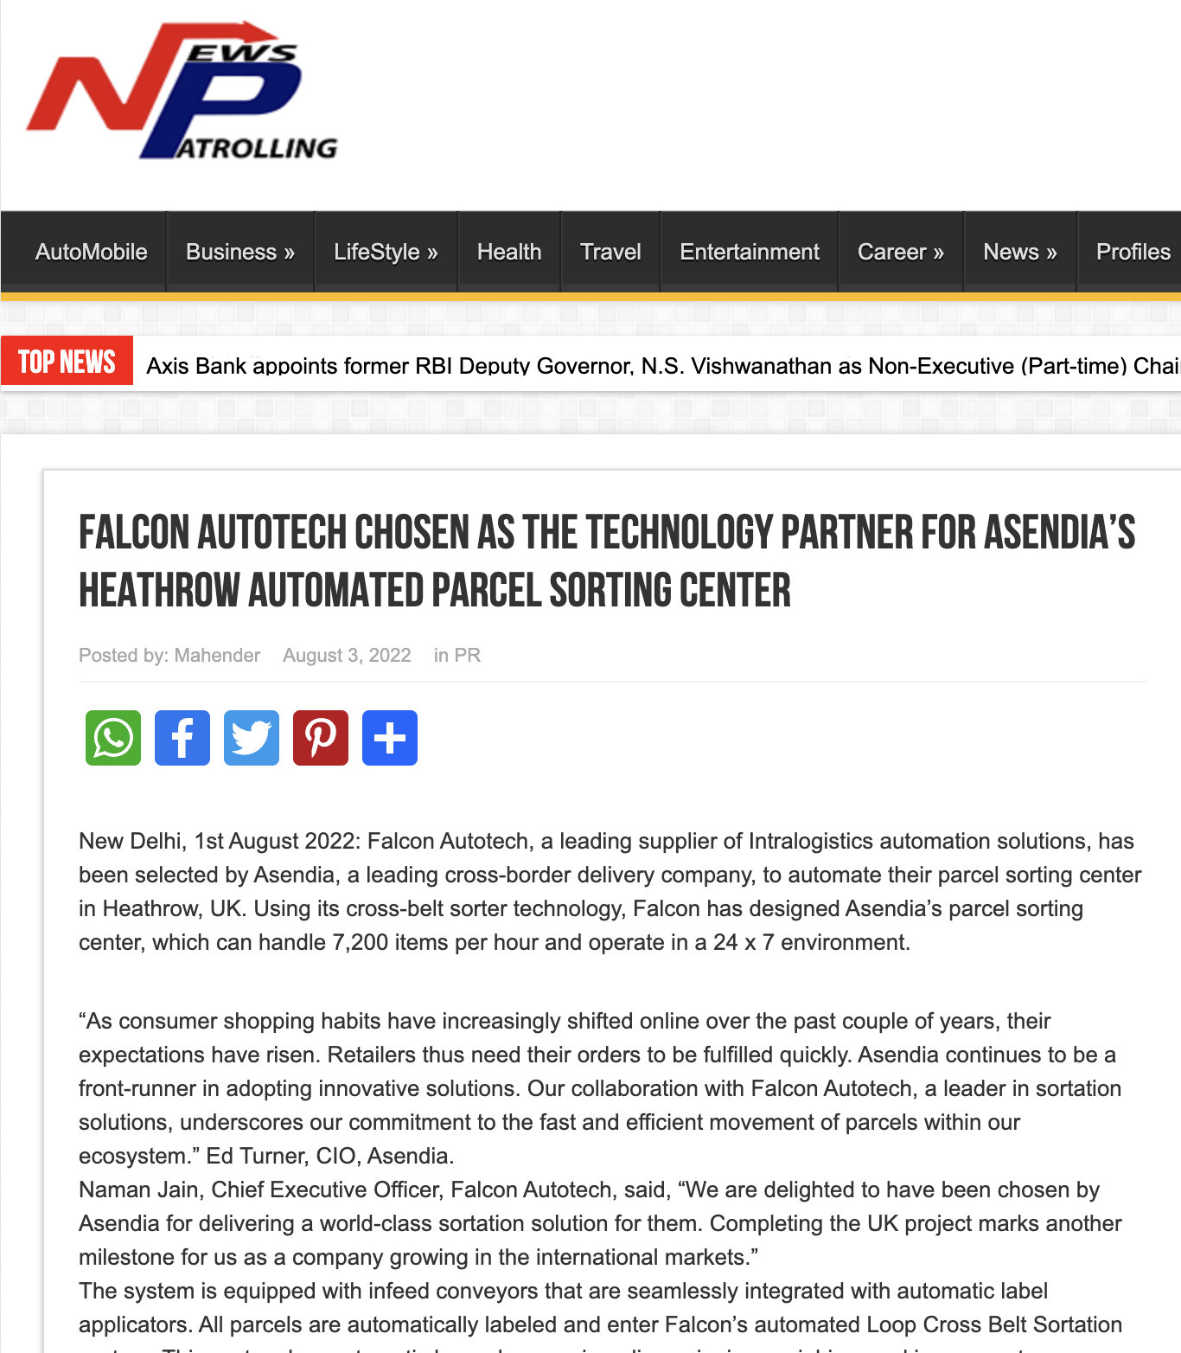

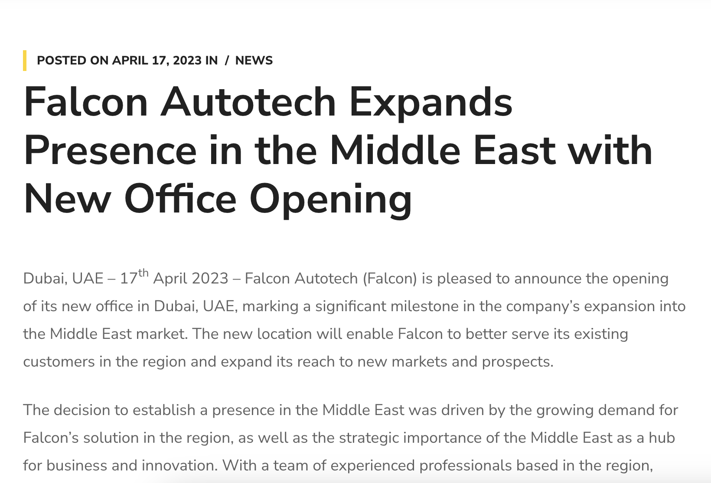



Reference Projects
Falcon has a strong legacy in Warehousing Automation solutions and references-

- Expertise in Shipment Sortation, Piece Picking and Handling, Case Picking and Handling.
- Lifecycle services (maintenance, spares supply chain, support).
- Full in-house expertise (Hardware/Software).
- Turn-key tailored solutions.
The references list presented below focuses on Sortation Solution –

Project 1- (CEP Client, India)
The System is equipped with two fully automated and interconnected Sub-systems. Sub-System 1 is designed for handling large B2B boxes and E-commerce shipment bags while the Sub-System 2 is designed to handle Small E-commerce packages.
Solution Specifications –
  - 48,000 PPH (Double Deck CBS- Shipment Sorter)
  - 17,000 PPH (Double Deck CBS- Bag Sorter)
- Building Size: 700,000 Sq. Ft
Key Technology Modules –

- 2 Sets of Double Decker CBS Sorters
- Mezzanine Structures (one large mezz on to install a double decker Sorter).
- Automated Singulators
- Fully Automatic Inductions
- Semi-Automatic Inductions
- Telescopic belt conveyors
- PVC Belt Conveyors
- Modular Belt Conveyors
- Spiral Chutes with Braking rollers
- 5-Sided Scanning Tunnels
- High speed weighing conveyors
- Direct Bagging Chutes
- Put to Light Chutes
- Volume Distribution systems
- High Availability Server Systems
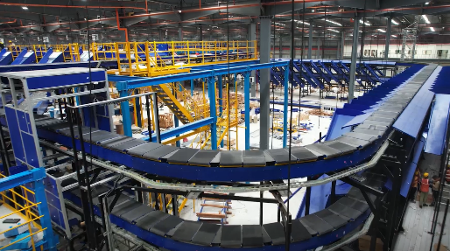
- WCS
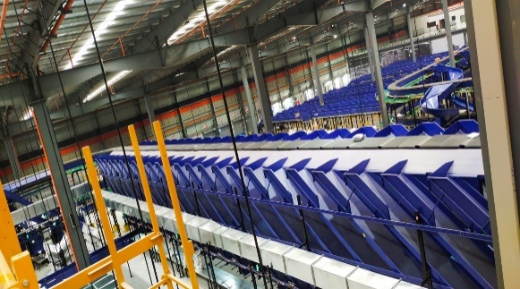
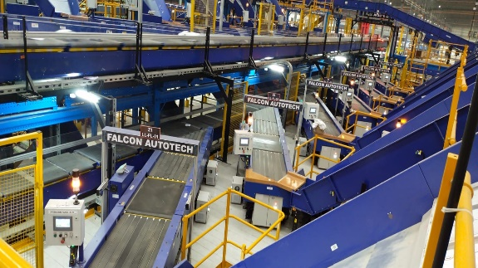
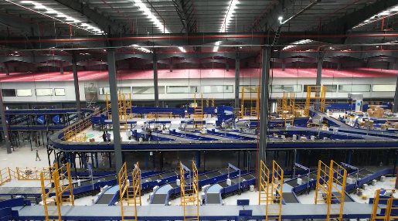
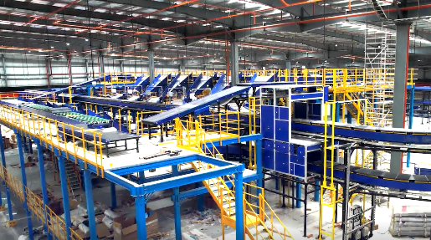
Site Pictures -

Project 2- (Client – E-Commerce, India)
Use Case – Destination Sorting of Packed Shipments.
In 2019, Client was looking for a potential automation partner for design and development of a new automated sortation system for B2C shipments. The system should be able to provide maximum uptime with reduced dependency on skilled manpower, and space optimization.
The customer chose Falcon Autotech based on its unique design which could cater to all their pain points, capability of seamless integration with WMS and life cycle support services.
Solution Specifications –
- Throughput: 27,600 PPH
- End Destinations: 410 Direct Outputs
- Building Size: 200,000 Sq Ft
Key Technology Modules –
- Bulk Infeed Conveyors.
- ARB based Volume Distribution System
- Integrated Presort System.
- Irregular Ejection System.
- Automatic Induct Lines.
- Automatic Barcode Scanner with Image Capture.
- Automatic Weight & Volume Measurement System.
- Loop Cross Belt Sorter.
- Smart Sliding Chutes for Direct bagging and Cage Sorting.
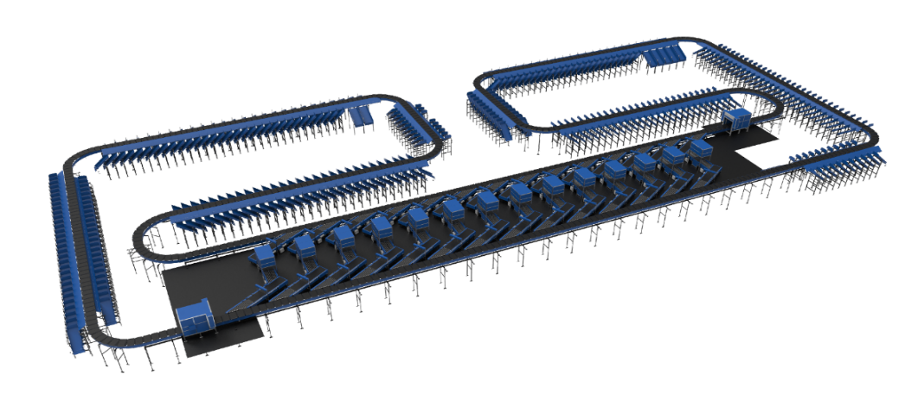
- Bag take out system
- WCS Software System.

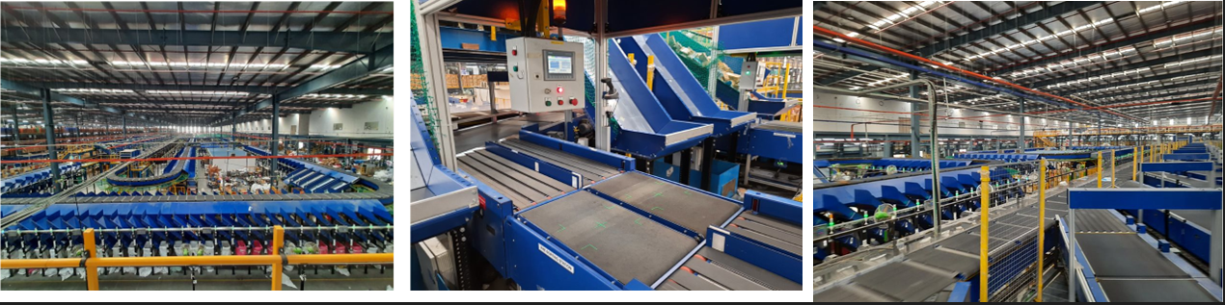

Project 3- (Ecommerce Client, India)
Use Case - Destination Sorting of Packed Shipments
Solution Specifications –
- Throughput: 24,000 PPH
- End Destinations: 110
- Building Size: 200,000 Sq. Ft
Key Technology Modules - Loop Cross Belt Sorter with a cell size of 900 x 500 mm
Layout and Site Pictures -
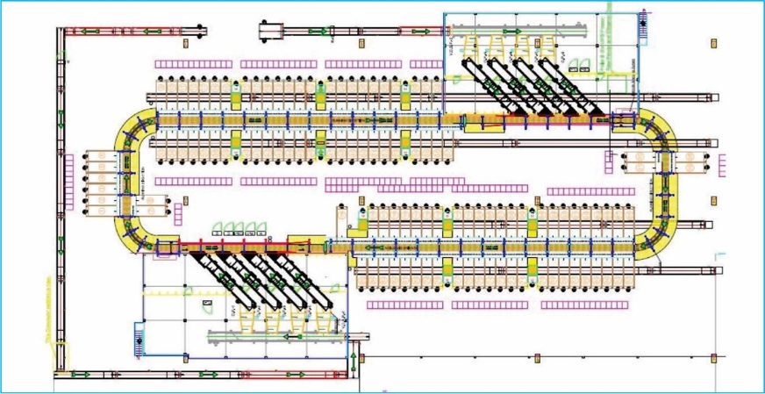

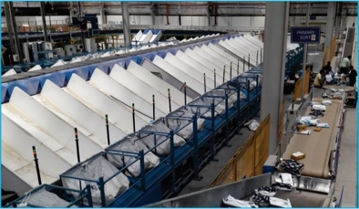
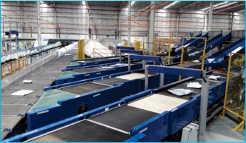

Project 4- (CEP Client, UK)
This Solution is designed to handle a volume of 7200 shipments per hour. The system is equipped with three infeed conveyors integrated with an automatic label applicator before shipments enter the sortation system. The shipments are sorted using Falcon's Loop Cross Belt Sorter equipped with automatic barcode scanning, dimensioning, weighing and image capture capabilities. The sorter is installed on the mezzanine floor and sorts directly to 58 end destinations.
Solution Specifications –
- Throughput: 7200 PPH
- End Destinations: 58 Nos
Key Technology Modules –
- Powered Belt Conveyors.
- Automatic Induct Lines.
- Automatic Barcode Scanner with Image Capture.
- Automatic Weight & Volume Measurement System.
- Loop Cross Belt Sorter.
- WCS Software System.
Site Picture –
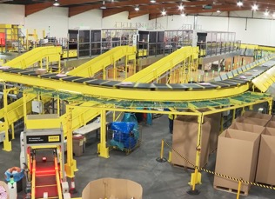

Project 5- (CEP Client, Sydney)
Solution is designed for handling a throughput of 16,000 shipments per hour with the help of Falcon’s Loop Cross Belt Sorter. The system consists of 2 feeding zones with a total of 10 feedlines. Sorter design enables the van drivers to directly drop the shipments at the dock doors. It has a total of 369 end destinations that are achieved with a combination of direct drops and PTLs. System is integrated with 5 side automatic barcode scanning, weight and volume measurement and automatic detection of oversize and overweight shipments.
Solution Specifications –
- Throughput: 16000 PPH
- End Destinations: 369 Nos
Key Technology Modules –
- Powered Belt Conveyors.
- 2 Induct zone.
- 5 side Automatic Barcode Scanner.
- Automatic Weight & Volume Measurement System.
- Automatic detection of oversize shipment.
- Loop Cross Belt Sorter.
- WCS Software System.
Site Picture –
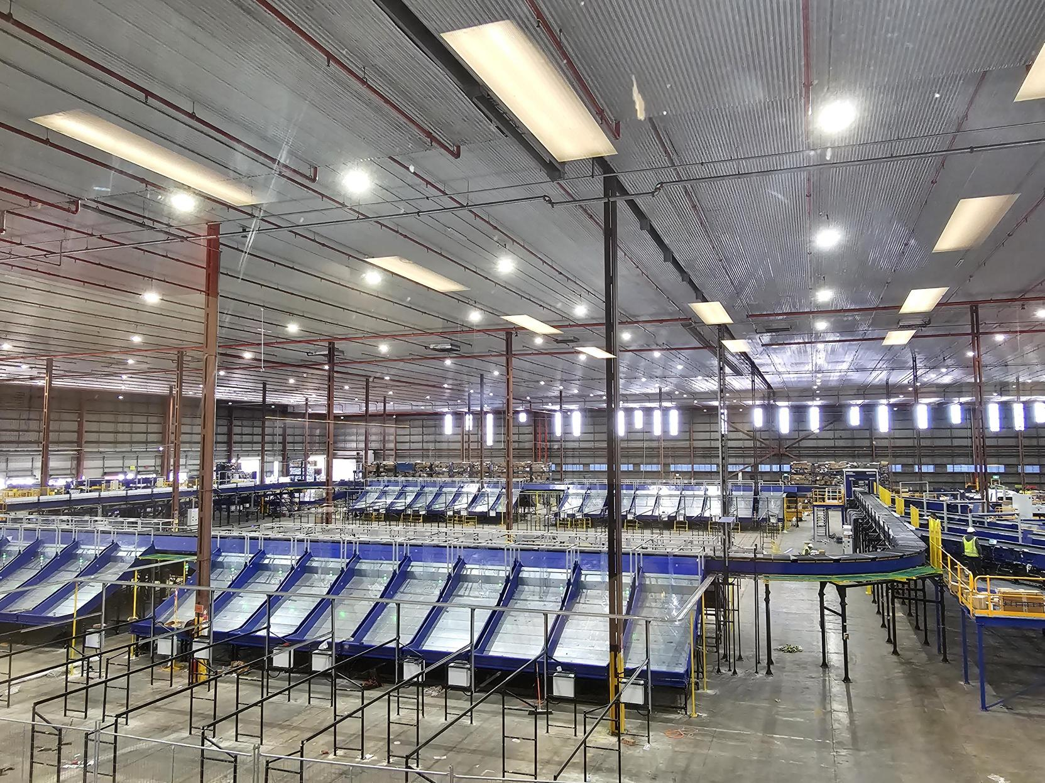

Handled Shipment Spectrum

Specification | Unit | Value
Max Length | mm | 1000
Max Width | mm | 800
Max Height | mm | 750
Max Weight | Kg | 50
Min length | mm | 100
Min Width | mm | 100
Min Height | mm | 50
Min Weight | gm | 200
Dimensioning Accuracy | mm | +/- 10 for length, Width & Height
Weighing Accuracy | Kg | +- 0.06 or 0.5 %, whichever is higher

Shipments to be loaded on Sorter shall have the following characteristics:

- Centre of Gravity of item must not move during conveyance or sorting.
- Item must not have magnetic content, otherwise behavior of shipment cannot be guaranteed.
- Liquid or fragile material, to avoid breaking, spillage or leakage, such as wine bottles, metal cans of paint are designated as non- conveyable items.
- Shipments shall be perfectly and safely packaged: protrusion or open surfaces are not allowed.
- Plastic ropes shall be perfectly adherent to the surface of the package.
- All items with the risk of being damaged during the transport on an automatic sorting system or
damaging the sorting system. They must be robust enough to avoid disintegration of container material and loose of contents in the sorting process.
- Item packaging shall have enough grip to be handled on the belts during the acceleration and
referencing phases.
- Items shall not have slippery surfaces and must be able to withstand acceleration of the items on the belt during the start-stop phases (accelerations up to 0.5 g shall be assured without any sliding or tumbling of the items on the belt conveyor).
- The shipments must have at least one flat and regular surface providing enough stability during conveyance.
- All shapes are permitted except spherical, cylindrical, or alike unstable items & shapes.
- All usual packaging materials are permitted (including paper, carton, plastics, plastic foil, rope, tape, textile, and wood)

Shipment not loadable on the sorter

All products that are not within the range as described here, are considered non- conveyable products, and must be taken out of the main sorter flow by the operators.

- Unstable items with a risk to roll or tumble on the sorting system, such as spherical or cylindrical items.
- Items that have a spherical or cylindrical shape.
- Items that are packed in material that can damage the conveyors or the sorter.
- Items that have sharp points (e.g., Nails) or sharp edges, that can damage the conveyors or the sorter.
- Fragile shipments with contents not sufficiently secured.
- Items that have been classified as dangerous are designated.
- Wet items are designated.
- Items with anti-slip treatment.
- Items with protruding parts.
- Items with sharp edges.
- Inadequately packed items that could be damaged during automatic transportation.
- Electrostatically loaded items.
- Loose parts on loads and load carriers, such as adhesive tape, stickers, slips of paper, straps, wrap foil etc. are designated as non- conveyable items.

Proposed System Description

Objective
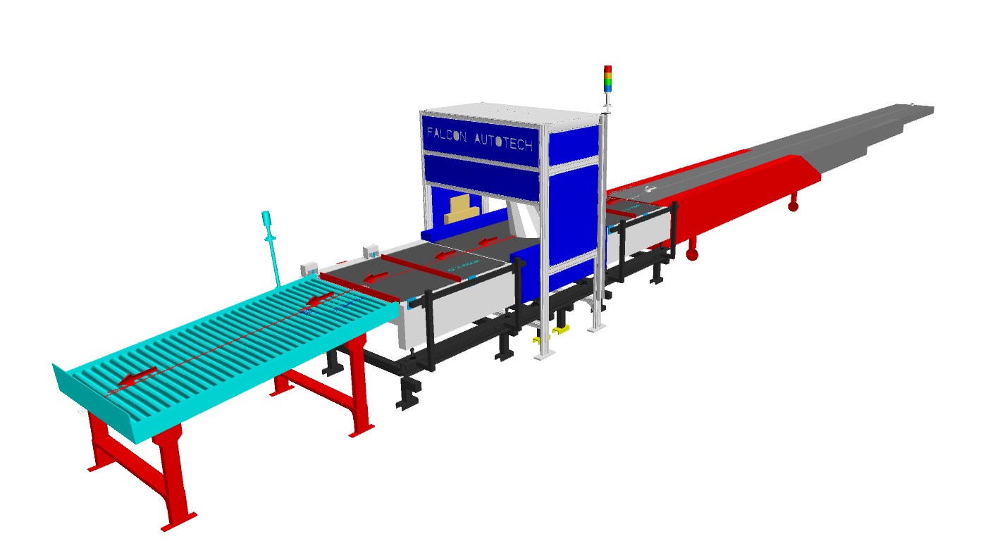
The purpose of this proposal is to present the design, manufacturing, installation, commissioning, testing, and acceptance testing of the Telescopic Belt Conveyor & Dynamic profiler as per Flipkart’s requirements.

Summary of the System

Process flow of the System
Infeed System: - The Shipments will be loaded on telescopic belt conveyor, then these shipments will proceed to Dynamic profiler for further process..
Profiling: - The resource will orient the shipment such that barcode always faces the scanner (Top Side only). The shipment passes through the automatic barcode scanning tunnel where the barcode data is read, the weight, dimensions and image are captured and stored in the system. The system then passes on to the output conveyor.
Exception Handling: - In case of over weight & over dimension parcel, tower light indicates the error & the conveyor stops, Operator is expected to remove the parcel from the output conveyor & handle it manually outside the system.

Main benefits of the proposed solution
The proposed solution has the following advantages:

- Increased Efficiency
- Fewer Personnel Required
- Flexibility, Improved Safety, Space Utilization
- Precise Measurements
- Minimized Shipping Errors
- Better inventory tracking and management
- Seamless Integration with existing warehouse management systems (WMS)

System Components

Telescopic Belt Conveyor

A telescopic belt conveyor is a highly versatile and efficient material handling solution designed to streamline the loading and unloading process in various industrial applications, particularly in warehouses, distribution centers, and shipping docks.

Some Salient Features of telescopic belt conveyor:
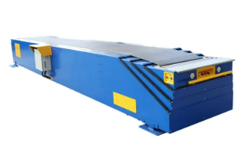
    - Versatile
    - Space efficient
    - High safety standards.

Specification | UOM | Remark
Manufacturer Name | Name | Falcon Autotech
Suitable Carton Weight | Kg | Min 5, Max 25
Base Length | Mm | 6000
Extended Length (Total Length) | Mm | 24000
Conveyor Belt Running Speed | m/min | 18-30
Motor Rating | Type | 0.75 Kw, 415V AC, 50 Hz
Load Capacity | Kg/m | 50
Communication | Mm | 2 x RS243, 1 x USB2.0, Ethernet

Orientation Conveyor and Output Conveyor

Falcon’s Powered Belt Conveyor is used for Shipment Loading/Orientation and as receiving/output conveyor.

Some Salient Features of Falcon’s belt conveyor:

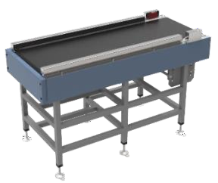
    - Low Noise
    - Maximum uptime.
    - Minimal maintenance
    - High safety standards.
    - Fastest ROI

Specification | UOM | Remark
Manufacturer Name | Name | Falcon Autotech
MOC of Belt | Type | PVC
Belt Thickness | mm | 3
Belt Finish | Type | Matt Finish
Usable Belt width | mm | 1000
Belt Make/Model No. | Make | Forbo/Derco/Similar
Load capacity per unit length of Conveyor | kg/m | 60
Type of Motor | Type | AC Geared Motor
Type of Drive System | Type | Direct Shaft Mounted Motor/ Flange Mounted
Type of Drive | Type | Chain drive/Torque Arm type

Weighing Conveyor

Falcon’s weighing conveyor is used for inline weighing of parcels.

Some Salient Features of Falcon’s weighing conveyor:

    - High Speed Weighing
    - Minimal maintenance
    - High safety standards.
    - High accuracy

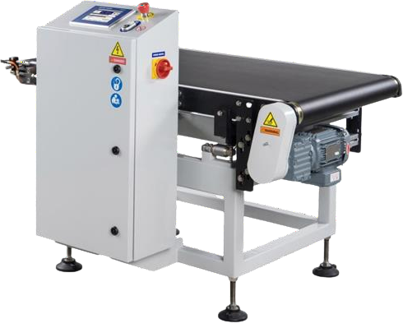

Specification | UOM | Remark
Manufacturer Name | Name | Bizerba
Handled Product Sizes | Mm | Min: 100 x 100 x 50  Max: 1000 x 800 x 750
Minimum Weight | Kg | 0.2
Maximum Weight | Kg | 60
Weighing Accuracy | Kg | +- 0.05 or 0.5% of product weight, whichever is higher

Auto Barcode Scanning System

System is integrated with automated Camera technology for scanning 1D/2D Barcodes. Some Salient Features of Falcon’s Scanning System:
    - High Speed Scanning
    - High Accuracy Rates
    - Effortless Operation
    - High safety standards.

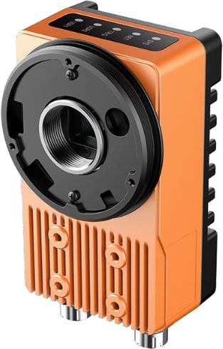

Specification | UOM | Remark
Manufacturer Name | Name | Hikvision
Barcode Type | Type | 1D/2D
Module Size | Mils | >=10
Handled Product Sizes | Mm | Min: 100 x 100 x 50  Max: 1000 x 800 x 750
Number of Codes | Nos | 1
Location | Side | Top
Orientation | Type | Omnidirectional
Color of bars | Color | Black
Under Foil | yes/no | No
*SOP to Follow: Large parcels to be fed in the system such that the barcode is on the top face and at the leading end of the parcel.

Idler Roller Conveyor
Falcon’s Roller conveyors require negligible maintenance leading to very minimal Operating costs and thus lower cost of ownership.
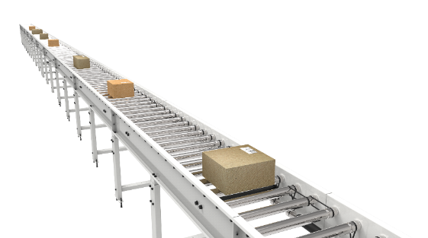
Some Salient Features of Falcon’s idler roller conveyor:
- Low Noise
- Maximum uptime.
- Minimal maintenance
- Comes with MS frame.

Specification | UOM | Remark
Manufacturer Name | Name | Falcon Autotech
Material of Roller | Type | MS Rollers with Zinc Plating
Overall Width | mm | 1000
Conveyor Height | mm | As per Layout requirement
Load capacity per unit length of Conveyor | kg/m | 50
Roller Span | mm | approx. 600
Roller Diameter | mm | approx. 50
Pitch of Rollers | mm | 75
Type of Mounts | Type | Fixed Heights Legs with Grouting Provisions
Type of Guides | Type | Yes
End Stopper | yes/no | Yes

Proposed System Technical Details

Mechanical equipment

Pos. | Qty. | Description | Value
1 | 1 | Infeed System  - Telescopic Belt Conveyor  - Orientation Conveyor  - Auto Barcode & Imaging System  - Auto Dimensioning System  - Weighing Conveyor  - Output Conveyor  - Idler roller conveyor | 1 Nos  1 Nos  1 Nos  1 Nos  1 Nos  1 Nos  1 Nos

Electrical Equipment

Electricals
1 | 1 | Consists of  Main Control Panel  Field Cabling | Included

Control System

Components
1 | 1 | Consists of  Weigh Scale Control, Barcode Scanner Controls, Dimension Scanner Controls  Control IT Software Package | Included

Key Components Make

Items | Make
TBC | Guanchao/ Wangman
Orientation Conveyor | Falcon
Volume Scanners | Hikvision
Weighing Scales | Bizerba
Sensors | Sick/Leuze/ P&F
Control Panels | Rittal/ BCH

Program Organisation
Dispatch within 12-14 weeks from the date of signed PO, advance and DAP whichever is later

Commercial Terms

Price Sheet
Non-Large Shipment Sorter
S. No | Component | Set | Price (INR)
1 | Telescopic Belt Conveyor | 1 | ₹ 14,00,000
2 | Dynamic Profiler | 1 | ₹ 26,00,000
3 | Conveyor & Components | 1 | ₹ 83,100
4 | Software Packages | 1 | ₹ 2,36,000
5 | Installation & Commissioning | 1 | ₹ 1,23,573
6 | Packaging & forwarding | 1 | ₹ 82,327
7 | Project Management | 1 | ₹ -
Grand Total (INR) |  |  | ₹ 45,25,000

Bundel price for Six Quantity | ₹ 2,71,50,000
Discounted Bundle price for Six Quantity | ₹ 2,64,30,000

The Total Price is to be understood.
- Ex Works – Greater Noida, India
- Freight charges shall be extra at Actual.
- Taxes, Customs, Duties extra at actuals
- Including Packing and Forwarding
- Duty unpaid
- Including Installation and Commissioning
- Price is valid for 60 days from the date of proposal.

*Material Unloading & Laydown area is in customer scope

Payment Terms

Payment Percentage | Stage
20% | Advance along with PO against ABG
50% + 100% taxes | Material received at Site
20% + 50% 0f I&C | Against erection
10% + 50% 0f I&C | Acceptance and complete handover against PBG

Warranty Period
Falcon’s offered System comes with a standard warranty of 1 year (Starts from the date of beneficiary use).
The warranty covers the following support:
- 24 X 7 Telephonic, Email and Remote Service Support when required.
- Regular Software updates and Bug Fixes.
- Supply of Mechanical and Electrical components in case of failure (excluding damages as mentioned in the Exclusion Clause)
The warranty does not apply to the replacement or repair of:
- Normal wear and tear.
- Consumables.
- Faulty articles continued:
  - Failure to comply with the manufacturer's recommendations (logistics documentation, Technical Information Note, retrofit document) and the rules of the trade.
  - Negligence or abnormal use of equipment.
  - Anomalies produced by an environment of use, storage or transport that does not comply with the specifications or recommendations of Falcon: packaging, temperature, hygrometry, sector, insulation, etc.
  - A defect due to a cause external to the supplies and services of Falcon.
- Equipment other than that supplied by Falcon.
- Items that can be repaired exclusively by Falcon that have been repaired or attempted repairs other than those carried out by Falcon.
- Items that fail due to normal wear and tear of one or more of its components or whose tamper-evident seals (varnish, strip, etc.) have been broken or whose serial numbers have been removed or modified.
- Items damaged during transport to Falcon due to the use of unsuitable packaging.

Exclusions

The scope of supply includes all parts which are defined in the Supplier’s quotation.

All other parts which are not defined in the Supplier’s quotation do not belong to the Supplier’s scope of supply and are excluded. The following parts are also excluded:

- Server System
- Mobile Carts
- Construction Power
- Steel Works- If not specified
- Collection Trolleys below chutes
- Secondary Sortation
- PC for SCADA.
- Fans at chutes & Inducts.
- Building infrastructure; building structure, doors, fire exits, levelling devices, building extinguisher and fire alarm system, building heating and lighting system.
- Electrical power supply and wiring to the main control cabinets.
- UPS for Controls and Drives
- Network Cabling up to the Main Server Rack
- Intermediate wiring to parts which are to be supplied by the Purchaser/others.
- Emergency/Uninterruptable power supply
- Fire-alarm and fire protection devices.
- Traffic and route markings
- Laydown Area
- Ram protection devices
- Cat walks, bridges, maintenance aisles and platforms
- Assembly tools like forklifts and hoisting machines
- All kind of network incl. Local Area Network (LAN/WLAN), exceeding the scope described in Scope of Supply
- Any Kind of Civil work
- Any adjustment of the Supplier’s scope of supply to local rules and regulations
- X-Ray machines
- Roller cages/ Pallets
- Simulation and 3D animation of the sorter system
- Interface with other equipment not specified in this offer.
- Provision of facilities for the control room (furniture, air conditioning, heating, etc.).
- The supply and installation of fencing around the different corridors.
- Any item specifically indicated as not forming part of the subject matter of the Seller's supply in the offer documentation.
Thank You

